

12600 Airport Rd.
Maxton, NC 28364
Phone: 910-844-1177
Website: http://acoustonegrillecloth.com

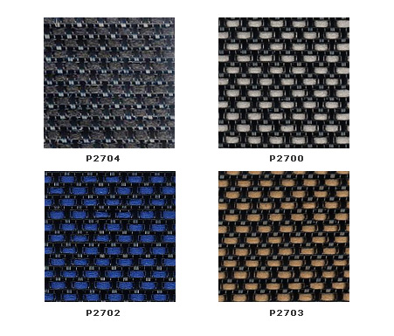
Technical Data Sheet
DESCRIPTION Acoustone Speaker Grille Cloth is designed and engineered for sound transmissibility and an aesthetic appearance. The unique and versatile qualities of the speaker grill cloth make it suitable for a wide variety of applications.
The engineered fabric construction allows sound to pass through the synthetic threads with minimum interference. The result is a top-quality speaker grill cloth engineered for sound reproduction.
Acoustone Speaker Grill Cloth is suitable for covering speakers in a range of applications. (Please see chard below)
Acoustone Speaker Grill Cloth is flame retardant, mildew proof, has excellent fade resistance and is easily cleaned by vacuuming or light soap and water. Acoustone Fabrics will not fray at the edges after binding.

TECHNICAL CHARACTERISTICS
SIZE: Sold by the linear yard
WIDTH: 36”, 72”
LENGTH: Linear yard
MATERIAL: Polypropylene and Polyester
FIRE RESISTANCE: Class 1 or A per ASTM E84
NFPA-701-2004 (Passes)
COLORS: Variety of Colors
APPLICATIONS
• Auditoriums and Theaters
• Recording Studios
• Home Theaters
• Media Rooms
• Worship Facilities
• Sports Arenas
• Indoor or Outdoor Use (not in direct weather)
• Architectural Designs

